November 28, 2018

Mr. Cameron Smith [*Delivered*](mailto:regcomments@ncua.gov) *at hearing*

Department of Consumer and Business Services

Copy: Mr. Andrew Stolfi and Ms. Janet Powell  
Division of Financial Regulation

350 Winter St NE

PO Box 14480

Salem, OR 97309-0405

**Subject:** Minimum Number of Credit Union Board Meetings: Defining “regular board meetings” as six meetings per year; Establishing OAR 441-710-0527

Dear Mr. Smith:

During the 2017 Legislative Session, Oregon Revised Statute 723.292 was amended by House Bill 2161. The Bill removed the language requiring credit unions to meet on at least 10 separate times per year and instead provided the Director of the Department of Consumer and Business Services with authority to specify the minimum frequency of board meetings. As a result of this statutory change, the Division of Financial Regulation (DFR) has proposed to define “regular board meetings” as a minimum of six regulator meetings per year with at least one meeting held in each of the four quarters. The Northwest Credit Union Association (Association)[1] appreciates the opportunity to submit comments and urges the DFR to adopt the rule allowing credit unions’ board of directors to meet, at a minimum, six times per year. We also ask that DFR consider all bylaws updated in accordance with this rule to be automatically approved by the Credit Union Program Manager, without need of any formal approval by the DFR or the Program Manager.

**General Comments**

The Association appreciates the Division of Financial Regulations’ leadership acknowledging Andrew Stolfi, Janet Powell, Richard Blackwell, and Lauren Winters, among others, for their work on this administrative rule. The rule will not only provide efficiencies for credit unions, but it will also help credit unions realize a cost savings associated with a reduced administrative burden incurred with each board meeting.

As the dynamics of credit unions’ boards of directors continue to evolve, it is important that credit

unions can offer their volunteers a modern and flexible meeting schedule. Reducing the number

__________________________

The Northwest Credit Union Association is a regional trade association representing the interests of more than 180 credit unions and their 6.5 million consumer-members; institutions that employ and engage more than 19,000 people and hold more than $90 billion in aggregate assets. The Association is a nonpartisan advocacy organization representing the interests of its member institutions on a variety of systemically important banking issues.

Credit unions affiliated with the Association are principally domiciled in Idaho, Oregon, and Washington, but the Association also has members from the states of Alaska, California and Hawaii. Learn more about the Association at [www.nwcua.org](http://www.nwcua.org).

of minimum board meetings enables credit union volunteers to take advantage of other resources

available to them, such as online board portals and more training opportunities, and strikes a balance between their volunteer requirements and other outside commitments. Additionally, the rule still provides touchpoints for the volunteers by excluding from the definition of “regular board meetings” other meetings such as the credit union’s annual meetings, committee meetings, or special meetings. We appreciate the flexibility that this new definition will provide.

**Specific Comments**

Historically, Oregon credit unions expect to hear back when submitting bylaw changes even though amendments to bylaws submitted to the director in accordance with ORS 723.022 become effective 30 days after submission. The Association does urge the DFR to add language to the rule that would deem bylaws updated in accordance with OAR 441-710-0527 automatically approved upon submission to the Credit Union Program Manager instead of requiring an approval from the Credit Union Program Manager or waiting 30 days after submission to consider the bylaws approved, as is currently required. The boards of directors must ensure that the update is in the best interest of the credit union and in compliance with applicable rules and regulations. Since a change in the number of regular meetings from any stated amount to a minimum of six would be done so in accordance with this new rule, more efficiencies and clarity would be gained by both the credit union and the Credit Union Program Manager if any change to bylaws made in accordance with this rule were deemed automatically approved upon submission. The statute still provides the DFR with the ability to require additional board meetings at their discretion at any point.

**Conclusion**

The Association would like the DFR to adopt the rule defining regular board meetings as six meetings per year with one occurring in at least each quarter.

The Association asks that the DFR also allow for credit union bylaws updated in accordance with this rule be deemed approved without any further need for approval from the DFR.

Thank you for the opportunity to comment on this issue. We would be pleased to answer any questions you may have.

Respectfully,



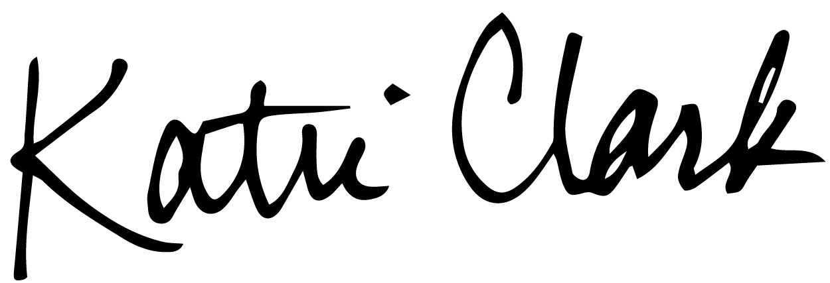

Katie Clark Seth Schaefer

Director, Regulatory Compliance & Risk Management President/CEO

Northwest Credit Union Association Rivermark Community Credit Union

1.